Chapter 11, 13, 14, & 15 Objectives

Comparable Questions may be asked in class, on quizzes, and on exams

Students will be able to:

* + explain how a sector is related to a track, and then how a track is related to a cylinder in multiple disk hard drive
* A track is divided into segments of **sectors**, which is the basic unit of storage
* A **cylinder** is comprised of the set of tracks described by all the heads (on separate platters) at a single seek position. Each cylinder is equidistant from the center of the disk
  + explain how the FCFS hard drive scheduling algorithm is better than the SCAN scheduling system
* FCFS is very simple, Processes are processed in the order in which the service queue is placed, regardless of where the head is located, It can be likened to FIFO in a queue.
* The SCAN algorithm is unfair to recently scanned regions and, therefore, it is not as good at accessing locality as FCFS algorithms
  + explain how the SCAN hard drive scheduling algorithm is better than the SSTF scheduling system
* **SCAN** is The arm starts at one end of the disk and moves to the other;
* As each cylinder is moved, the request is processed.
* When the other end of the disk is reached, the head movement reverses and processing continues.
* The head scans the disk back and forth
* **SSTF** is It may make sense to process all requests close to the current head position before moving the head elsewhere to process other requests.
* This assumption is the basis of the ShortestSeekTimeFirst (SSTF) algorithm
* It overcomes the disadvantage of shortest seek first, considering both distance and direction.
  + explain how the SSTF hard drive scheduling algorithm is better than the LOOK hard drive scheduling system
* **LOOK** is very similar to SCAN but Unlike SCAN, in this the head instead of going till last track, it goes till last request and then direction is changed.
* LOOK doesn’t serves the task request which is closest to current position of head or pointer. It means LOOK needs more time than SSTF, this is how SSTF is better than LOOK especially when systems with heavy disk load
  + explain how the LOOK hard drive scheduling system is better than the FCFS hard drive scheduling system
* **FCFS** Scheduling is based on the order in which a process requests access to the disk
* Advantage : Avoid unnecessary head movement
  + briefly describe the mirroring process for a RAID system
  + briefly describe the striping process for a RAID system
  + briefly describe the use of block interleaved parity with a single parity disk aka block-interleaved distributed parity
  + briefly describe the difference between a two-level directory structure and a tree structured directory

In this separate directories for each user is maintained.

* Path name:Due to two levels there is a path name for every file to locate that file.
* Now,we can have same file name for different user.
* Searching is efficient in this method.
  + 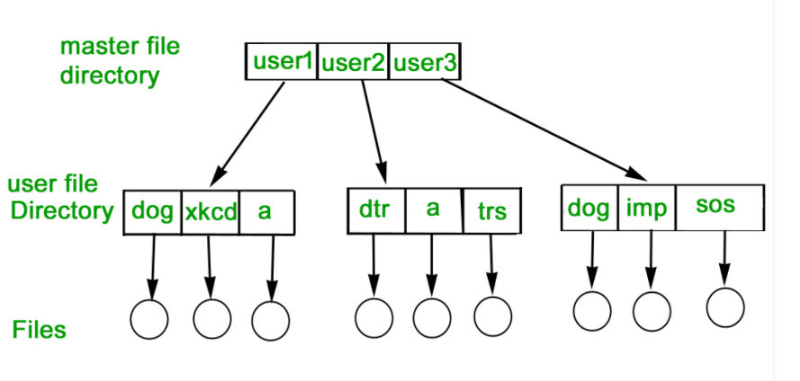
  + **TREE-STRUCTURED DIRECTORY :**  
    Directory is maintained in the form of a tree. Searching is efficient and also there is grouping capability. We have absolute or relative path name for a file.
  + 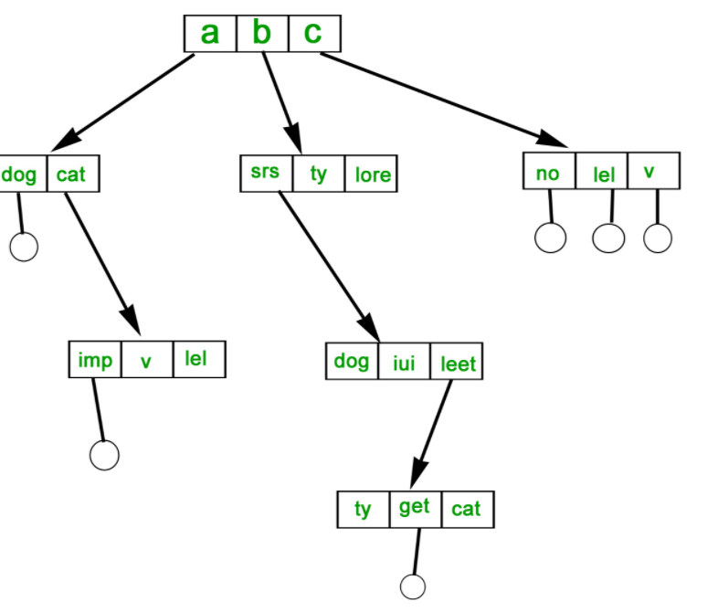
  + identify and describe three types of OS operations that might occur with a file
  + briefly describe and/or compare contiguous allocation, linked allocation, and/or indexed allocation, and provide an example
* contiguous allocation When a file is created, a contiguous set of blocks is allocated; Each file in FAT (document allocation table) has only one entry, indicating the starting block and the file length. Good for sequential files
* 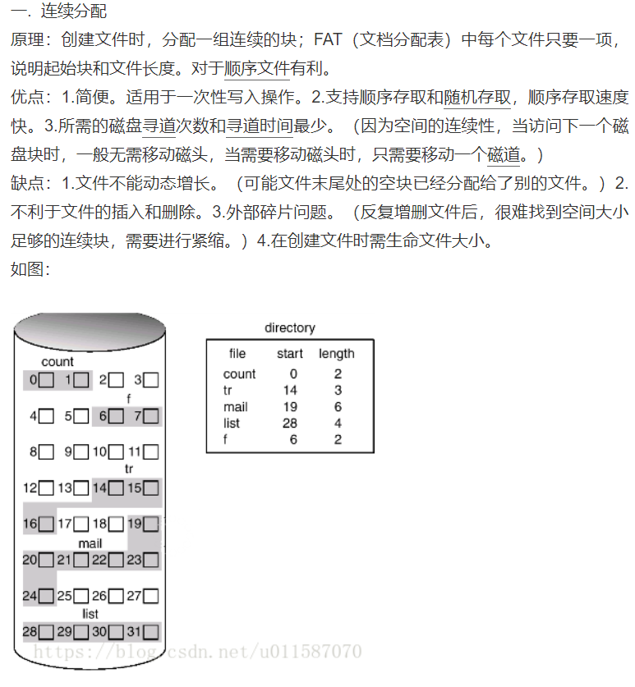
* linked allocation Information about a file is stored in discrete physical blocks connected by Pointers, with the first physical block pointing to the next. Once again, each file in FAT requires only one item, including the file name, the starting block number, and the last block number. Any free block can be added to the chain.
* 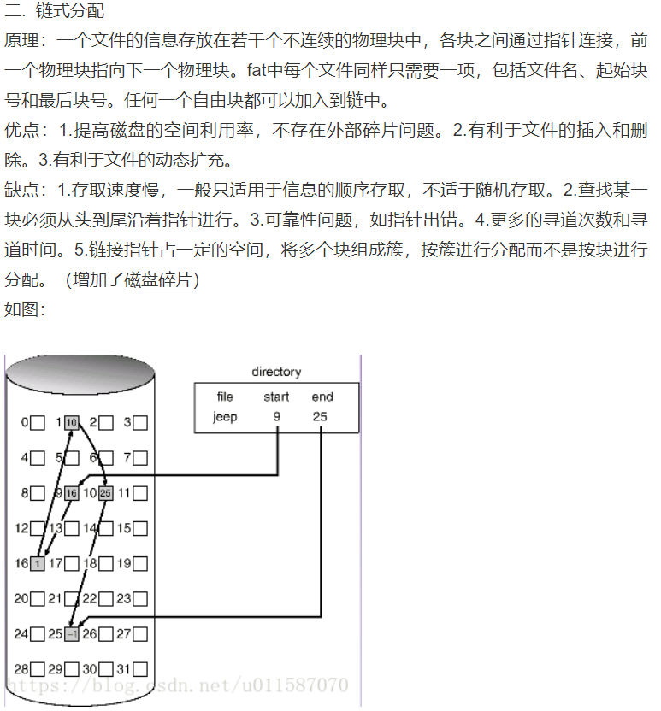
* indexed allocation Each file has a first-level index in FAT that contains the entry for each partition assigned to the file. The index of the file is stored in a separate block, and the entry of the file in FAT points to this block
* 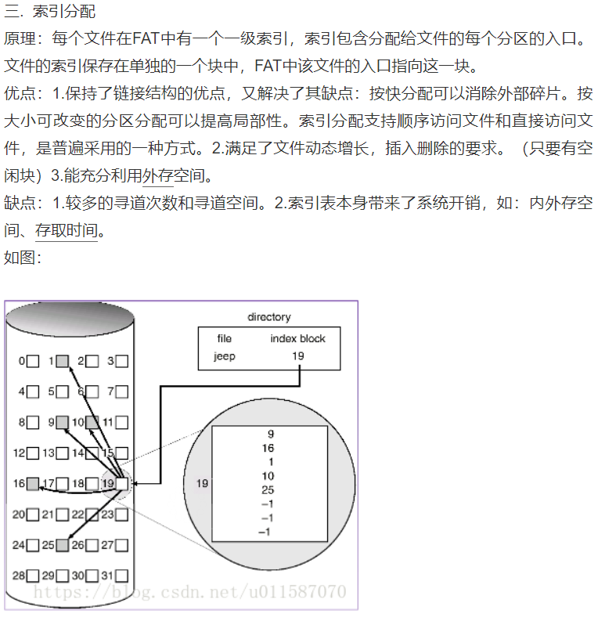
  + given specified conditions such as number of address bits, or size of a storage block, conduct calculations that would demonstrate storage conditions using an iNode and/or graphically show the use or operation of the iNode
  + Briefly describe what VFS and NFS are, and explain how they might be used in a given computing system
* NFS is an open standard defined in request for Comments (RFC) that allows anyone to implement the protocol.
* "VFS" is the name of the entire layer in the kernel between the system call and the  filesystem drivers. But Itself is not a file system; it can Provides a standard file operation interface for the application layer